CHESHIRE’S LANDMARK EDWARDIAN THEATRE | THRILLING AUDIENCES SINCE 1911

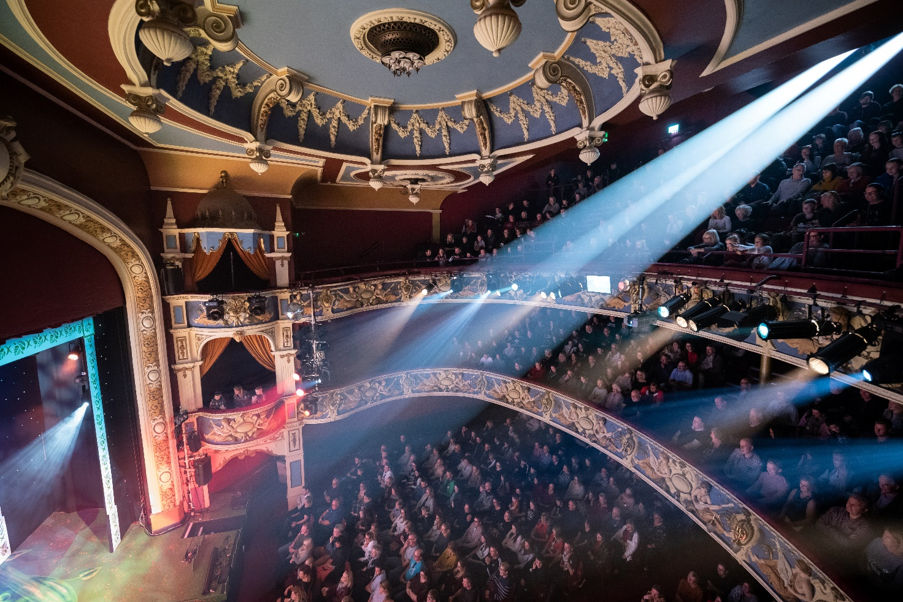

Deputy Building &
Technical Manager

Job Description
Person Specification
(Revised deadline - January 2020)
Crewe Lyceum is one of 13 venues within HQ Theatres & Hospitality (HQT&H) current portfolio of regional theatres and concert halls. HQT&H currently manages 19 auditoria on behalf of local authorities, with capacities ranging from a 200 seat arts centre to a 2,400 seated/standing theatre. Last year HQT&H programmed a total of 2,354 shows which attracted attendances of over 1.5 million. HQ Theatres & Hospitality (HQT&H), the UK’s second-largest venue operator, is a division of Qdos Entertainment Ltd, one of the largest entertainment Groups in Europe. www.hqtheatres.com

Crewe Lyceum Theatre is Cheshire’s landmark Edwardian theatre with 677 seats and an elegant and comfortable auditorium which is in excellent decorative and operational order and has been thrilling audiences since 1911. Now operated by HQT&H, the Company has significantly invested in the fabric of the building from period frontage through to breath-taking Edwardian auditorium. The building now presents itself as a comfortable and pleasing entertainment complex in which to enjoy theatre, entertainment and hospitality. Working in partnership with Cheshire East Council, we have launched a new programme of Creative Learning, Engagement and Professional Development. Supporting our renewed focus on engagement this investment includes the transformation of the former English Touring Theatre rehearsal facilities into a brand new, multi-purpose 110 seat Studio to widen the reach of the Theatre’s performance activities, outreach work and further develop our audience potential. www.crewelyceum.co.uk

Employment type: | Full Time
Salary: | £25,000 to £27,500 p.a. dependent on experience, ability and potential
Hours: | 40 hours per week, on a rolling annualised hours basis, to meet business requirements. These hours may be varied and may include evenings, weekends and Bank Holidays as necessary to meet the demands of the business and your post.
Work location: | You will be based at the Lyceum Theatre, Crewe and may be required to travel to and work at other HQT&H venues. Approved travel expenses will be reimbursed.
Purpose of the role: | Deputise for the Building & Technical Manager, lead the full time, casual, and apprentice technicians in providing the highest standard of technical, maintenance and health and safety support for visiting companies, external hirers and venue teams.
Our ideal candidate: | An excellent all-round technician with proven success in stage, general maintenance, health and safety and people support management. You will be comfortable in a fast-paced environment and able to remain focused under pressure of shifting priorities … all whilst maintaining a positive outlook and a good sense of humour!
For an informal discussion contact: | Carl Knapper, Buildings and Technical Manager  01270 508787
Closing date: | Monday 27th January 2020 at 2pm
How to apply: | Download and complete an application form from www.crewelyceum.co.uk and email to recruitment@crewelyceum.co.uk with the subject title ‘Deputy Building & Technical Manager’. You can also apply by post to Lisa Cruise, Theatre Administrator, Crewe Lyceum, Heath Street, Crewe, Cheshire CW1 2DA.  Tell us why you think you are suited to this role, why it interests you and how we will benefit from having you on board!

REPORTING

You will report directly to the Building and Technical Manager.

The posts you will line manage in this role include Technicians, Casual Technicians and Apprentice Technicians.

KEY ACCOUNTABILITIES

Strategic

- With other members of the Technical Team, contribute as required to the achievement of the Lyceum Theatre’s Business Plan and its relevant targets and objectives.

- Deputise for the Buildings and Technical Manager in their absence in respect of all responsibilities associated with the running of the Technical department and its team.

Operations

- Ensure timely and effective pre-liaison and preparation for all performances, hires and events, facilitating their smooth running and operation and ensuring visiting companies and hirers experience an excellent visit to the Lyceum Theatre and Studio.

- To assist the Buildings and Technical Manager in ensuring the maintenance and safe operation of all stage, electrical and sound installations, plant and equipment, so as to achieve the Lyceum Theatre’s service targets.

- As required, undertake operation of sound and lighting controls and related equipment and / or act as duty stage-manager for rehearsals, performances, hires and events.

- To ensure that riders and appropriate information are received from any client using the Lyceum Theatre and Studio, with enough time to ensure resources are in place prior to the event, and that all resources are detailed on recharge sheets as necessary.

- With the Buildings and Technical Manager roster Lyceum Theatres’s technical department, ensuring correct staffing across all spaces and utilising the full time technical team and the casual staff lists to both operational and financial benefit.

- To assist and supervise with moving scenery and equipment during a production, working with lighting, sound and special effects as directed by the Building and Technical Manager.

- To assist and supervise visiting production companies and performers with the get-in and get-out of all staging and electrical equipment as directed.

- Supervision of staff in the Buildings and Technical Department, including monitoring and performance management.

- To liaise with other departments as to their technical requirements and set ups for events.

- With the technical team, to work closely and promote good customer relations with all visiting producers and artists and in particular with amateur companies.

- Carry out routine maintenance on the Lyceum Theatre’s equipment and systems as directed by the Buildings and Technical Manager

- To assist and supervise in the management of contractors and the general maintenance of the buildings and facilities as required – including routine and general maintenance tasks such as lamp checks, Portable Appliance Testing, painting etc.

- To be a designated key-holder and to undertake and ensure the safety and security of the building at all times. This includes attending to alarm call outs as required.

Health & Safety

- In liaison with the Buildings and Technical Manager, ensure that consumables stock is correctly maintained and any venue purchases are specified and actioned in accordance with department procedures.

- To develop a good working knowledge of the building’s facilities and services in order to carry out assigned maintenance duties to a high standard, as directed.

- To assist and supervise in protecting and safeguarding the buildings and their contents from possible theft, damage and abuse by carrying out assigned duties as directed and abiding by policies and procedures issued.

- To abide by relevant Health and Safety and Licensing requirements and to ensure all visiting performers, contractors, staff and the general public also conform to these requirements.

- Ensure the safety and comfort of staff, customers and clients at all times whilst on the premises.

Recruitment, Training and Development.

- Arrange and deliver in-house training and staff briefings, ensuring they are correctly documented.

- Assist the Buildings & Technical Manager in the recruitment and on-boarding of building and technical department staff, including provision of support to induction and training, as appropriate.

- Undertake training and development relevant to the successful execution of the job role.

Other Responsibilities

- Any other duties as required from time to time, taking into consideration the grade of the post and capabilities of the employee.

- Dress in accordance with Company uniform policy and wear protective clothing where issued and instructed.

- Attend and, if required, chair and note take meetings as required.

PERSON SPECIFICATION

In order to be considered for this post you will need to evidence and demonstrate:

Experience

- At least 4 years’ previous backstage or technical experience in either a professional, educational or performance environment
- Previous experience of managing and training staff in a team leader or supervisor capacity with a minimum of 2 years’ experience at this level.
- Previous experience working with lighting, sound or special effects
- Proven ability to effectively work in a multi-tasking environment
- An understanding of electrics including the rigging of stage lighting systems.
- Proven experience operating stage machinery, including counterweight hemp, electric motors and chain blocks
- Practical experience in equipment maintenance
- Fault finding experience, with the ability to repair technical equipment proficiently, safely and to a high standard

Skills

- Able to take and act upon instructions within a given time frame and in a busy working environment
- Ability to work safely at height, using ladders and tallescope, and from lighting bridges
- Able to use own initiative
- At least an intermediate level of Outlook, Word, Excel and/or other IT

Knowledge

- Knowledge and use of theatre lighting and sound systems, including rigging, focussing and plotting
- Knowledge and use of counterweight flying systems
- A working knowledge of technical theatre practices, including terminology and knots
- An understanding of security requirements in a technical environment
- A working knowledge and understanding of technical health and safety legislation and rules

Qualifications

- PAT Testing qualification

Attitude

- Ability and willingness to work weekday daytimes, evenings, weekends and on Bank Holidays
- A strong customer service focus and a genuine desire to deliver an excellent experience, every time
- Enthusiasm for the performing arts and entertainment
- A ‘can-do’ attitude and a positive, flexible approach to the job role, work colleagues and peers
- A presentable, professional and approachable manner which sets an example for others to follow

The following are desirable attributes, experiences and qualifications that would be beneficial to the post:

Desirable Knowledge, Experience and Attributes

- An understanding of theatre and entertainment protocols, such as DMX etc
- General knowledge of building maintenance, operations and plumbing
- Previous experience of using BMS controls
- An understanding of fire safety, including previous experience operating fire alarm panels
- Experience of working with young people
- A good sense of humour
- A working knowledge of the Artifax diary management software

Desirable Qualifications

- First Aid qualification
- Accredited Tallescope Training
- Accredited Health & Safety training
- Full clean driving licence

This Job Description is not an exhaustive description of the duties associated with this post. You will be required to adopt a flexible approach to your role and responsibilities. In particular, from time to time, you may be required to undertake such alternative or additional duties as may be commensurate with your skills, experience and capabilities.

