JOB DESCRIPTION:
Technical Manager at Hollesley Bay Hall, HMP Hollesley Bay, Suffolk

Job Title | Technical Manager
Employer | Second Stage (second-stage.org)
Location | HMP Hollesley Bay, Rectory Rd, Woodbridge, Suffolk, IP12 3JW.
Times of work | 3½ days Mon-Thu (tbc) 08:30-17:00
Start Date | May 2026 (Fixed Term 1 year, 3½ days per week)
Salary | tbc

Second Stage, a charity created to develop partnerships between prison leavers and the live events industry, are recruiting an experienced theatre/live events technician to work at HMP Hollesley Bay, Category D, male open prison, in Suffolk.

The Hollesley Bay Hall Technical Manager will need to deliver entry-level production training, preparing the men for employment opportunities upon release. You will need a basic knowledge in lighting, sound, video and stage management and an awareness and ambition to develop training courses to include basic life and social skills to benefit the men on release.

You will need a genuine passion for live events and be looking to share that passion with a new potential workforce, made up of people who might have had limited opportunities and experiences in life. Working in close conjunction with the HMPPS and ‘through the gate’ support teams, in-prison specifically the Facilities Manager, the Education dept and the Employment dept.

The duties of the Technical Manager will mostly be completed within a 3 ½ day week Monday-Thursday, however may necessitate working some evenings as and when events may be staged. The technical course structure and length will be developed by the post-holder, meaning that the courses will be structured to fit the availability of the Technical Manager and around the other education and employment offerings within the prison, to maximise the efficacy of the programme and the availability of the right candidate. The course will be developed in consultation with the ABTT (Association of British Theatre Technicians).

The TM will also work closely with Second Stage to engage with the professional theatre industry on the potential recruitment of the prison-leavers. Supported by existing ‘through the gate’ networks, together with the team at Second Stage, you would support applicants through the application and interview process of recruitment into technical roles backstage in the live events industry.

This is a new and unique opportunity for the right candidate to be instrumental in creating and delivering the first ever theatre training in prisons.

Role and Responsibilities

As this is a new and unique position, the full breakdown of roles and responsibilities is not confirmed, but we envisage it including some if not all of the below.

- Manage the day to day running of the Hollesley Bay Hall
- Manage and maintain the bookings diary
- Liaise with the prison facilities manager on maintaining the equipment in the hall
- Schedule and deliver in-prison technical courses, in conjunction with Second Stage, to ABTT and other technical standards (tbc).
- To manage a budget for orders/re-stocks of consumable supplies
- Ensure the routine up-keep of the Hall including compliance with statutory Health and Safety legislation in liaison with the Facilities Manager and Governor.
- To provide a high level of technical education, supervision, advice and assistance to all staff and users of the equipment and Hall.
- To act as Production Manager for any in-prison performances, providing assistance to visiting professional and amateur productions. This may also include assistance with audio visual aids for lectures/talks.
- To take responsibility for construction or hire of sets, scenery and supervise all users.
- To supervise fit ups and strikes whilst rigging, plotting and focusing lanterns or when engaged in any technical theatre work.
- To be responsible for H&S in the Hall reporting to the Facilities Manager and H&S Advisor.
- To be the designated First Aider for the Hall
- To attend specific training for working with people with trauma in prisons (provided by Second Stage).

Qualifications and Education Requirements

GCSEs and post 16 further education, possibly higher education in an aspect of theatre production.
Industry experience essential.
Previous relevant education experience would be beneficial, though not essential.

Skills Requirements

Excellent knowledge of technical theatre and production processes. Some knowledge of set design and construction would be an advantage.
Outstanding communication skills, patience, diplomacy and adaptability. To be a cheerful team player who works with a genuine energy and enthusiasm for the work and who has a good imagination and sense of humour.
Experience of working with marginalised communities would be an advantage.
Ability to manage own time effectively and responsibly essential.
About Second Stage

www.second-stage.org

WHO WE ARE:

TRUSTEES
- Edward Snape, Theatre Producer
- Colin Howes, Corporate Lawyer at Harbottle & Lewis, Charity Law Association member and Director of Comic Relief.
- Emily Thomas, Governor of HMPPS (YOI) Isis
- Kash Bennett, Executive Director at Sonia Friedman Productions
PATRON/AMBASSADOR
- Michael Balogun, Actor (The Lehman Trilogy for National Theatre, Romeo & Juliet for Jamie Lloyd Productions, Henry VI, Part 1 for the RSC) with a personal lived experience of the criminal justice system.
EMPLOYEES
- Jo Hutchison – Executive Director
- Fiona Somerville – Operations Manager
- Jo Davies – Strategic Projects Manager

WHAT AND WHY:

- At the end of 2024 The Society of London Theatre (SOLT) and UK Theatre, the governing body for regional theatre, conducted a survey which resulted in a report stating that there is a shortfall in staff to fill backstage jobs across our UK theatres and skills shortages found across most technical roles, included here.
- In our research into marginalised communities who may not be aware of the theatre industry and the jobs available within it, we found that the opportunities being offered to prison leavers as part of their rehabilitation were limited and that there may be basic skills a prison-leaver might have, which could be easily transferable to an industry that has social care at its very heart.
- There has been plenty of media coverage around the government reports that the prison system is at breaking point, with its population having risen 80% over the last 30 years and in June 2024 was at 99% capacity, and remains critical despite the government’s early-release scheme.
- The cost-of-living crisis is exacerbating the already difficult time for those leaving prisons. The National Probation Service has been running at 120% capacity since January 2023, struggling to look after over the 200,000 people under its care, which also impacts on the ability to recruit and retain staff. These factors combined are impacting the mental health of those leaving prisons, causing additional problems with drug dependency and homelessness, which results in repeat offending which is costing the UK tax-payer over £18 billion a year.
- Documented success stories from other industries suggest that engagement, training and employment with those leaving the criminal justice system results in an engaged, diverse and successful workforce, as well as reducing re-offending rates substantially.
- Inspiration has come from the companies Timpson, Balfour Beatty, and Greene King, and the charities No Going Back, Only A Pavement Away and The Twinning Project, alongside success from theatre companies already working with prison leavers; Clean Break, Synergy, Geese and the Prison Partnership Project.
- In our early conversations with venues, theatre professionals and His Majesty’s Prison and Probation Services (HMPPS) we concluded that the theatre industry and its backstage job opportunities could provide a conducive and stimulating environment for those leaving prisons, if we can engage with them as part of their rehabilitation journey in prison, support them as they leave and help them negotiate the complexities of employment as prison leavers.
- The Second Stage initiative sits within two of this Government’s missions.
  - Kickstarting economic growth
  - Breaking down barriers to opportunity
- Live theatre is one of Britain’s most defining and influential art forms; it is the bedrock of the UK’s creative talent, both on and offstage, and the deep interdependence between our creative industries, proves that theatre serves as a vital training ground, continuously fuelling and being enriched by film, TV, radio, music and the video gaming sectors.
- With theatres located in communities across the country, we not only support local economies but also break down barriers to opportunities. Each theatre achieves this by enhancing creative education through participation and outreach work, and by providing training and pathways to low and highly skilled jobs on and off the stage.
- Second Stage has been created to support one of these pathways. In its work to engage with those leaving the criminal justice system, it offers an opportunity to explore a new community with a tolerant and welcoming workforce, who work collaboratively to deliver success via outcome focused teamwork. That working as part of a creative team with shared responsibilities provides its own rewards; that with transferable skills from trades including carpentry, electrics, construction, hairdressing and sewing, they might find a fast paced and adrenalin fuelled environment, within an artistic community.
- With reoffending rates currently costing the country £23billion, we believe theatre can play a vital role in reducing those rates as well as fulfilling two of the Government’s important missions.

Report on an unannounced inspection of HMP & YOI Hollesley Bay by HM Chief Inspector of Prisons 3-19 April 2024

https://hmiprisons.justiceinspectorates.gov.uk/hmipris_reports/hmp-yoi-hollesley-bay/

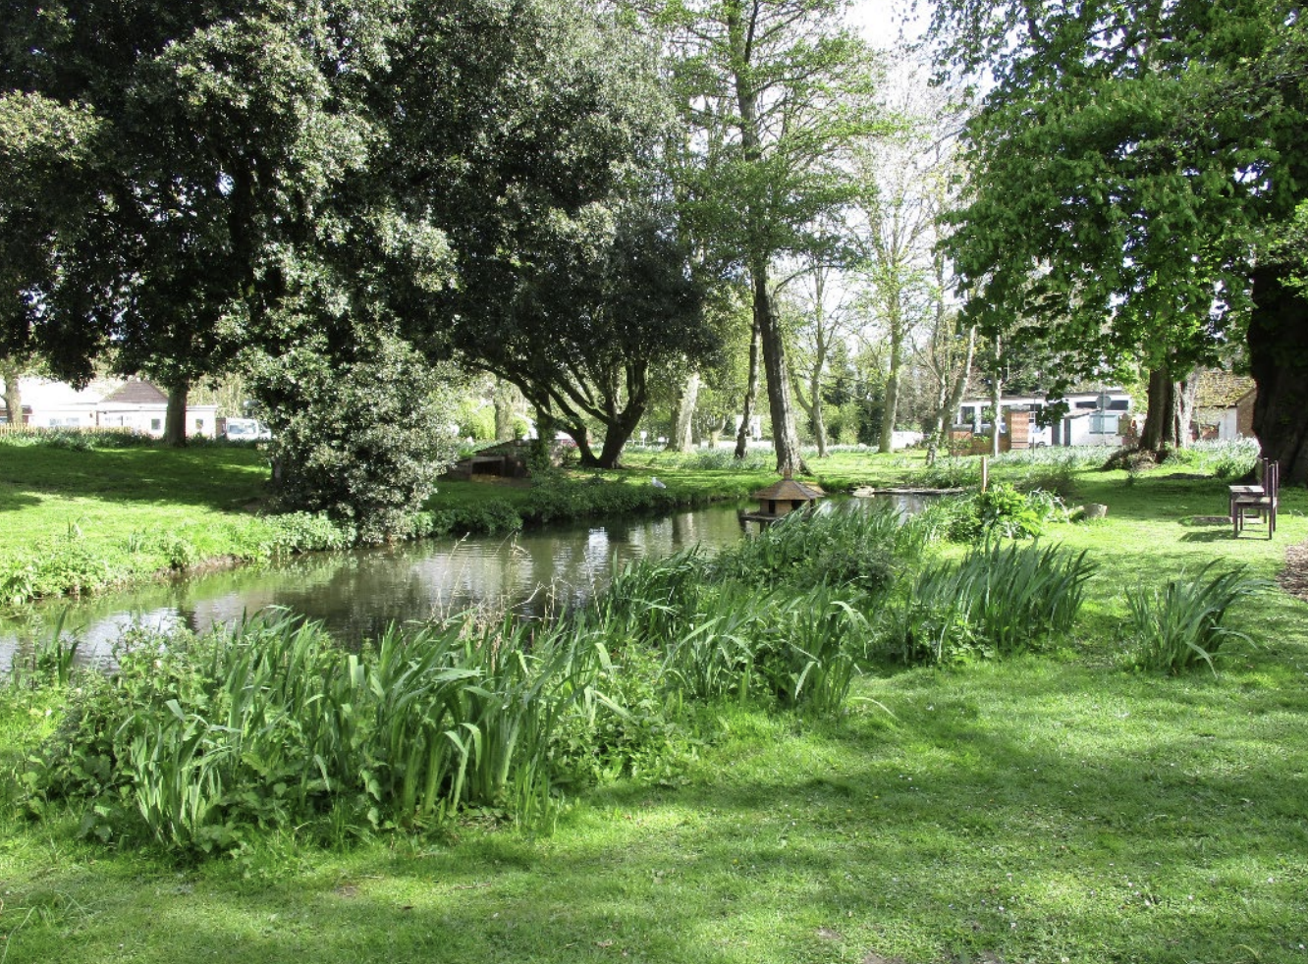

Hollesley Bay is a category D prison in the Suffolk countryside that, at the time of our inspection, held an expanded population of 627 men who were coming to the end of their sentences. Under the excellent leadership of a thoughtful, innovative governor and his strong team this safe, decent establishment had become one of the most impressive in the country.

At the centre of this was the sequencing of the prisoner journey through the jail. At induction, new arrivals were shown how they could earn trust and work towards moving into the best accommodation and opportunities to work off site. Even on the older units, prisoners lived in clean and well-ordered conditions, mostly in single rooms, with standards maintained at a weekly meeting of leaders. Prisoners who had proved themselves trustworthy lived in new pod accommodation, which was some of the best in the prison estate. Here there were opportunities for prisoners to shop for their own food and cook it in reasonably well-equipped kitchens.

The jail contained some of the better-run workshops I have seen in my time as Chief Inspector, where very effective staff supported prisoners to develop skills such as bricklaying, carpentry and horticulture. However, we found that some of the working hours did not mirror working conditions in the community, with prisoners returning to their units at lunch and workshops disappointingly closed on Fridays. Apart from a lack of accredited courses in English and maths, most education was of a good standard and attendance rates were high. Many prisoners did not have enough to do in the evenings or weekends because there were only very limited enrichment activities on offer. I was also disappointed to see that prisoners were not allowed to play ball games unsupervised because of health and safety rules. This seemed excessively cautious in a jail where prisoners could learn to drive a forklift truck and would soon be able to pass their HGV licence.

The prison had developed good relationships with employers, meaning 20% of prisoners were going to work outside the jail every day. This was further supported by the Employment Advisory Board who helped to identify employment opportunities for release. Although this was not as high as elsewhere, the governor had plans to develop further opportunities. Prisoners were reliant on an ageing fleet of minibuses that were costing a lot to keep on the road; money from the prison service for their replacement had, disappointingly, not been forthcoming.

The offender management unit was staffed by an impressive team who worked hard to support prisoners to progress through the end of their sentences. Unlike in other prisons, they allowed prisoners to drop in and ask for help. This was typical of the culture at Hollesley Bay where most staff were committed to supporting those in their care.
The busy employment hub provided excellent support for those who were about to be released and only very few prisoners left without accommodation to go to. The worrying public protection failings we highlighted at our last inspection had been resolved.

Leaders had worked hard to make sure that officer vacancies were filled, and that new staff were mentored in their first year at the jail. This had led to improvements in the retention rate with far fewer leaving. The governor, his team and the prisoners can rightly be proud of their achievements at Hollesley Bay. It is a place where innovation flourishes and prisoners are given every opportunity to acquire the sorts of skills that will help them to stay out of trouble and make a success of their lives when they are released.

Charlie Taylor
HM Chief Inspector of Prisons
May 2024

