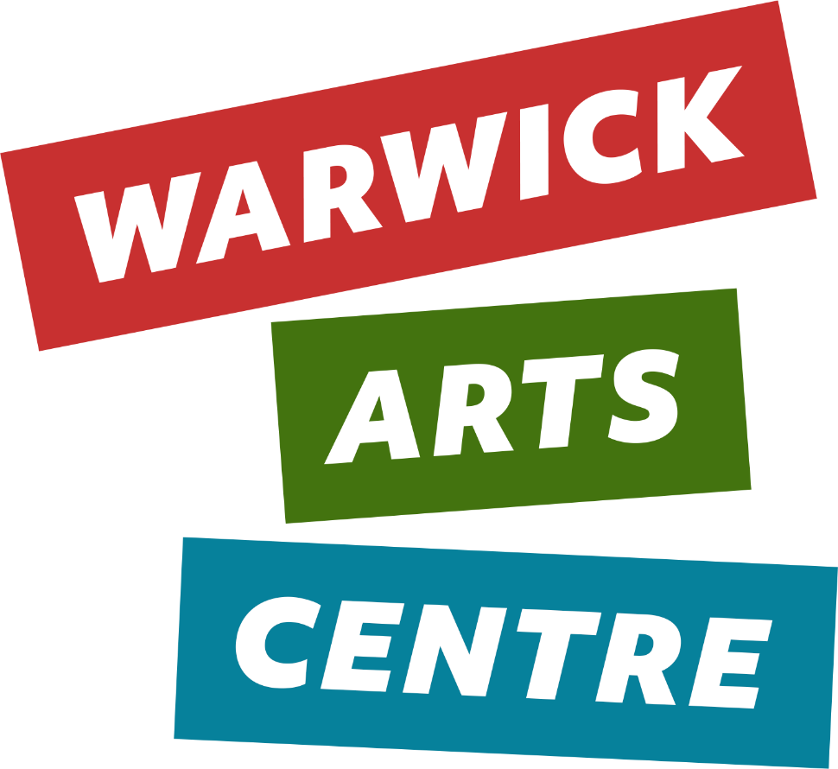

JOB PACK
Stage Technician
June/July 2026

Directors Welcome
Hi there,
Thank you for your interest in joining us at Warwick Arts Centre.
We are on a mission to create a dynamic, relevant, artistically ambitious and sustainable arts centre, and we need more great people to help us achieve our plans.
We are committed to creating an environment where everyone feels they belong, a place of fairness and equity and to be an organisation that reflects the diversity of its city. If this sounds like somewhere you would like to work, we would like to hear from you.
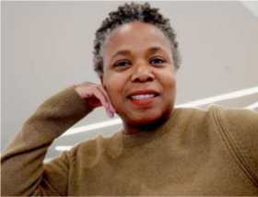
Good luck with your application.
© DAVEFREAK
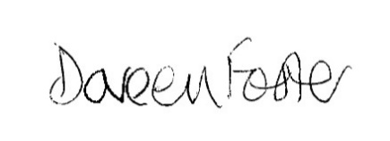

Doreen Foster
Director, Warwick Arts Centre

About Warwick Arts Centre
Warwick Arts Centre is the largest purpose-built arts centre outside London.
Opened in 1974 and situated at the heart of the University of Warwick, in Coventry, we're home to a variety of spaces including a 1,300 capacity concert hall, theatre, three cinemas and an art gallery.
With a wide-ranging, multi-artform programme, we've worked with some of the world’s most inspiring artists, among them Steve McQueen, Annie Mac, Dara Ó Briain, Pauline Black, Sara Pascoe, Sir Brian Cox, Sheku Kanneh-Mason, Rana Begum and Ken Loach.
Almost one million people visit us every year, with many more engaging in our activities across communities and other spaces.
We're passionate about the arts, and how it has the power to move, connect, inspire and present new possibilities; we're here to amplify under-represented voices, nurture the next generation of creatives, and serve as a vibrant and welcoming social hub for all.
More information about our events and activities can be found at https://www.warwickartscentre.co.uk/

Vision and Values
Purpose – We’re here to share our love for the arts
Belief – We believe the arts are a place we can all meet - a place to share our experiences, a place to find common ground and understanding, a place to connect, and have the courage to transform and explore new possibilities together.
Promise – Experiences you’ll feel and never forget – be it joy, excitement or sadness and whoever you are, wherever you’re from
The arts are an extraordinary source of wisdom, support, connection, understanding, joy and inspiration for each and every one of us. They are the human condition wrapped up in emotion and it’s our job to bring them to more people’s lives. In our evermore fragmented world, we believe the arts are one of the few places where we can all meet – a place to share our experiences, a place to find common ground and understanding, a place to connect, to transform and explore new possibilities together. It’s our job to change this, to bring people together through the arts and to create the connections that spark ideas and understanding.
More information about our vision and values can be found at https://www.warwickartscentre.co.uk/our-vision/

About the University of Warwick and Commitment to Equality
Founded in 1965, the University of Warwick is a world-leading institution known for its commitment to era-defining innovation across research and education. A connected ecosystem of staff, students and alumni, the University fosters transformative learning, interdisciplinary collaboration and bold industry partnerships across state-of-the-art facilities in the UK and global satellite hubs. Here, spirited thinkers push boundaries, experiment and challenge convention to create a better world.
Warwick is committed to building an organisation of mutual respect and dignity, promoting a welcoming, diverse, and inclusive working and learning environment. We recognise that everyone is different in a variety of visible and non-visible ways, and that those differences are to be recognised, respected, and valued. Where possible, we go beyond legislation to provide a place where everyone can thrive, supporting all staff to achieve their full potential. We aspire to remove economic, social, and cultural barriers that may otherwise prevent people from succeeding.
We therefore welcome and encourage applications from all communities regardless of culture, background, age, disability, sex/gender, gender identity or expression, ethnicity, religion/belief, or sexual or romantic orientation. More information about Warwick’s inclusion strategy can be found at https://warwick.ac.uk/services/socialinclusion/
Warwick Arts Centre is a department of the University of Warwick, and the successful candidate will be employed by the University of Warwick.
Role Information
We are looking for an experienced, adaptable, and technically skilled Stage Technician to join the team. We are committed to creating an environment where everyone feels they belong, a place of fairness and equity, and to being an organisation that reflects the diversity of its city. If this sounds like somewhere you would like to work, we would like to hear from you.
You will be an active member of the Technical Team and play a pivotal role in bringing live events to life, supporting the delivery of all technical aspects of both our live programme and conference events. It is essential that you are a communicative, collaborative, positive, and proactive individual.
In this role, you'll specialise as a Stage Technician, which will involve counterweight flying, load-ins and fit-ups, and the running of shows, together with AV knowledge and some basic lighting and sound operations. You will communicate well with our visiting companies and hires for incoming productions and events. Your primary responsibility will be to uphold the highest standards of technical presentation for all events while maintaining a keen awareness of health and safety regulations.
You will also assist with the timely maintenance of all equipment associated with the stage, auditorium, and rehearsal/hire spaces, and assist with the inspection of all installations and equipment to ensure compliance with current legislation and licensing requirements.
Flexibility is key in the event industry, and you'll need to be prepared to work flexible hours, including evenings and weekends. Please note that a 5% availability allowance is included in the advertised salary scale.
For full details about this role and to apply, please refer to the UniPerms website..

Online Information Session – Tuesday 7th July 2026 at 2:30pm
Join our Technical Manager and Technical Co-ordinator for an online information session. They will share details about Warwick Arts Centre, the role and objectives, and the application process. There will also be an opportunity to ask questions. If you cannot attend, we recommend registering so you can receive a copy of the session directly to your inbox the following day.
Register to attend here: https://events.teams.microsoft.com/event/05c0dba8-6d04-44fd-a519-217d5e7fe87e@09bacfbd-47ef-4465-9265-3546f2eaf6bc

Your Application
To apply for this role, you will be required to submit a CV and Cover Letter through the UniPerms website. If you need any support in submitting your application, please contact the UniPerms Team. We recommend following the below guidance to best support your application:
- Review the Job Description, Person Specification, Job Pack and information listed on the UniPerms advert page.
- Consider all the different types of roles you have had or work that you have done to support your application.
- For the essential criterion, it would be helpful to provide evidence/an example of what you have done that demonstrates that you have the experience, skills or knowledge we are looking for.
- Remember to tell us why you want to work for Warwick Arts Centre. Look at our website to make sure that you understand the range, scope and scale of our work. Explore our context and our role in the region. Consider the potential users of Warwick Arts Centre and how best to communicate its activity.
- Ask a friend/colleague to review your application and to check that you have provided examples and told the best story of your career to date and your ambitions in this role and the future.

Application Deadline: Sunday 19th July 2026.
Interview Date(s): Week commencing Monday 27th July 2026.

Thank you for considering to join us at Warwick Arts Centre. We wish you the best of luck and look forward to viewing your application soon.
