FOR IMMEDIATE RELEASE

WE’RE HIRING
The Orchard Theatre Announces Search for a New
Buildings and Technical Manager to
Lead Landmark Reopening

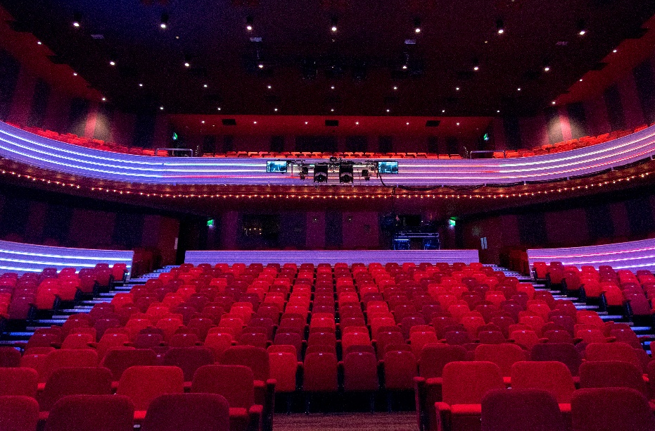

The Orchard Theatre Main Auditorium

Following a period of major refurbishment, Dartford’s iconic Orchard Theatre is officially launching a nationwide search for a visionary Buildings and Technical Manager. This pivotal Senior Management role arrives at an extraordinary moment in the venue's history, offering a rare opportunity to shape a lasting legacy and bring a much-loved regional cultural hub back to life for the community.
As the theatre prepares to reopen its main venue doors in December 2026, the incoming manager will inherit a state-of-the-art infrastructure. The role places the successful candidate at the heart of the venue's evolution, backed by the industry-leading Trafalgar Theatres network.

A Rare Opportunity to Work with Cutting-Edge Infrastructure
The Orchard Theatre is entering an exciting new chapter, backed by significant investment in brand-new, industry-leading technical systems. The Buildings and Technical Manager will have the unique privilege of working with and overseeing:
- Brand-new, state-of-the-art technology spanning lighting, sound, stage engineering, and communications systems.
- Comprehensive operational leadership, steering an exceptional, collaborative technical team, managing production requirements for incoming shows, and spearheading the technical production for the landmark annual pantomime.
- Building & capital project oversight, maintaining health and safety, compliance, and managing future capital works for Dartford’s premier entertainment venue.

From the Leadership
Tal Rosen, Theatre Director, comments: “This is an incredibly exciting opportunity to join a landmark project that will bring a much-loved regional venue back to life for Dartford and the wider community. We are looking for a passionate and experienced professional technical and facilities expert to help shape the next chapter of this iconic venue, delivering state-of-the-art facilities and an outstanding experience for audiences for years to come.”

The Orchard Team
Will West former Buildings and Technical Manager said, “Having spent 25 years at the Orchard Theatre... I can genuinely say this is one of the most fulfilling positions in theatre operations. What always stood out was the variety: no two days are the same, with the opportunity to shape productions, lead major technical projects, and have a real influence on how the venue evolves.
The technical team here are exceptional, supportive, collaborative, and deeply respectful of one another. Combined with a welcoming wider venue team and the backing of Trafalgar Theatres, it creates an environment where you can truly thrive. It’s an incredible opportunity and I’m genuinely excited for whoever takes it on.”
Will also adds, “I was fortunate to progress from this role into a Group Technical Operations position, now supporting venues across the UK. Trafalgar has a strong culture of developing talent internally, and The Orchard Theatre has been a fantastic springboard for many who’ve gone on to wider opportunities within Trafalgar.”

Key Requirements
The ideal candidate will bring a minimum of two years’ experience in technical theatre management or a senior technical role, with demonstratable capability in building maintenance, health and safety compliance, and team leadership.

How to Apply
Prospective candidates, who are ready to make their mark on the regional theatre landscape, can find the full job description and application details in the link below or by contacting Theatre Director Tal Rosen directly at tal.rosen@trafalgar.global
LINK TO FULL JOB DESCRIPTION AND APPLICATION HERE
Trafalgar Entertainment is an equal opportunity employer committed to diversity, inclusion, and empowering its teams to innovate in pursuit of excellence.
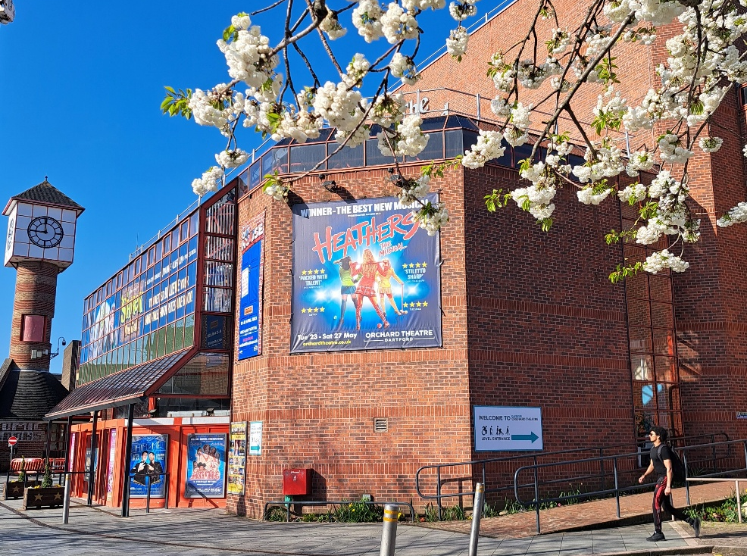
The Orchard Theatre

About The Orchard Theatre
Located in the heart of Dartford, The Orchard Theatre is one of the South East’s premier entertainment venues, renowned for bringing the magic of live performance to Kent and the wider community. Since first opening its doors, the theatre has stood as a vital cultural hub, offering a diverse, world-class programme that spans major West End touring musicals, top-tier comedy, drama, classical music, and its legendary, spectacular annual pantomime.
The theatre is entering a new phase following a major refurbishment programme and significant investment in upgraded facilities and technical infrastructure. This substantial transformation ensures that the theatre will continue to deliver an unparalleled, modern experience for both visiting artists and audiences for generations to come.
As part of the prestigious Trafalgar Theatres, The Orchard Theatre combines a warm, welcoming community atmosphere with the powerhouse backing of a leading global entertainment operator. Guided by a passionate, collaborative team and a commitment to innovation and excellence, the venue remains dedicated to inspiring, entertaining, and uniting audiences through the power of exceptional live theatre.
Media Contact: Kay Hadley, Venue Marketing Executive kay.hadley@trafalgar.global



